Name: Sanika Botre PRN: 25070122063
Batch: 2025-29 Branch: CSE A-2
Subject: Programming with Java

ASSIGNMENT No: 10

TITLE : Write a Java program to demonstrate the use of abstract classes and abstract methods

Problem Statement: Write a Java program to demonstrate the use of abstract classes and abstract methods

Learning Objectives: To implement abstraction using abstract classes and abstract methods.

Theory:

Abstract classes provide partial implementation of a program and cannot be instantiated directly. They may contain both abstract and concrete methods. Abstract methods declare functionality that must be implemented by subclasses. Abstraction hides implementation details while exposing only essential functionality. This improves code flexibility and maintainability in object-oriented programming.

Exercise:

1. Create an abstract Payment class and implement Credit Card and UPI payment classes.?

Code:-

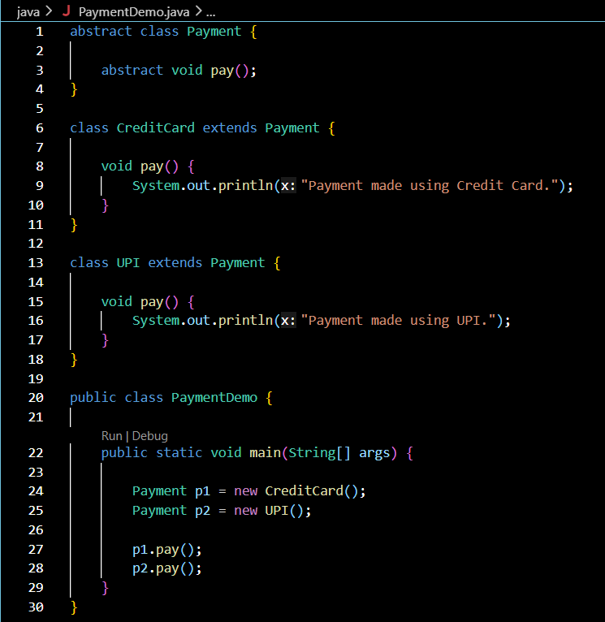

Output:-

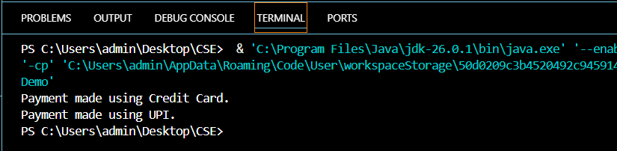

2. Create an abstract FoodOrder class with an abstract method calculateBill(). Implement two subclasses, DineInOrder and TakeAwayOrder, to calculate and display the total bill based on the order type.

Code:-

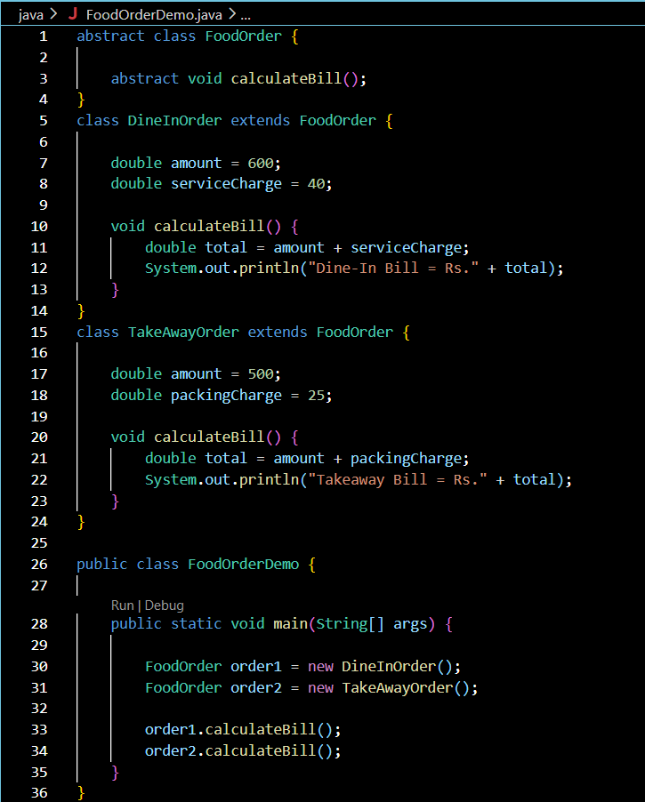

Output:-
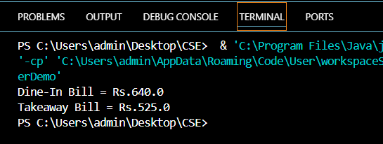

Conclusion:

his assignment successfully demonstrated the concepts of abstract classes and abstract methods in Java. The Payment and FoodOrder applications showed how abstract classes provide a common structure while allowing different subclasses to implement their own specific functionality. The programs executed successfully and illustrated the concept of abstraction, which improves code reusability and flexibility. Overall, this assignment enhanced the understanding of abstraction and its practical application in object-oriented programming.

